Displays a prompt in a dialog box, waits for the user to input text or click a button, and returns a String containing the contents of the text box.

**Following is an expanded InputBox**

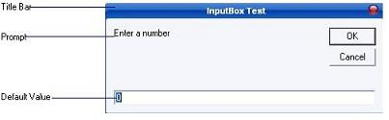

**Syntax :**

memory_variable = InputBox (prompt[,title][,default])

memory_variable is a variant data type but typically it is declared as string, which accept the message input by the users. The arguments are explained as follows:

* **Prompt** - String expression displayed as the message in the dialog box. If prompt consists of more than one line, you can separate the lines using the vbCrLf constant
* **Title** - String expression displayed in the title bar of the dialog box. If you omit the title, the application name is displayed in the title bar
* **default-text** - The default text that appears in the input field where users can use it as his intended input or he may change to the message he wish to key in.
* **x-position and y-position** - the position or the coordinate of the input box.

Following example demonstrates the use of InputBox function  
  
* Open a new project and save the Form as InputBox.frm and save the Project as InputBox.vbp

* Design the application as shown below.

|  |  |  |
| --- | --- | --- |
| **Object** | **Property** | **Setting** |
| **Form** | Caption  Name | InputBox test  frmInputBox |
| **Label** | Caption  Name | You entered  lbl1 |
| **Label** | Caption  Name  BorderStyle | ( empty)  lbl2  1-Fixed Single |
| **CommandButton** | Caption  Name | OK  cmdOK |

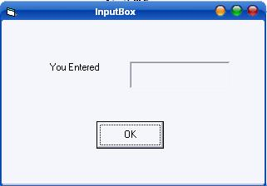

Following code is entered in **cmdOK_Click ( )** event

Private Sub cmdok_Click()  
Dim ans As String  
ans = InputBox("Enter something to be displayed in the label", "Testing", 0)  
If ans = "" Then  
lbl2.Caption = "No message"  
Else  
lbl2.Caption = ans  
End If  
End Sub

Save and run the application. As soon as you click the OK button you will get the following InputBox

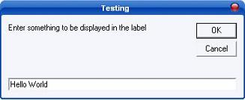

Here I have entered "Hello World" in text field. As soon as you click OK the output is shown as shown below

